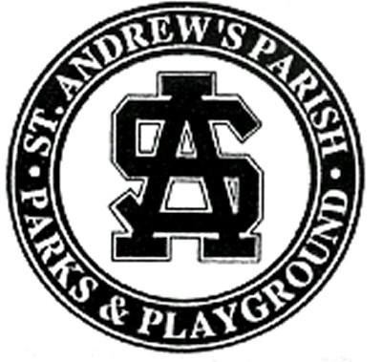
BACKGROUND
The Parks and Playground Hall of Fame recognizes individuals who have made outstanding and lasting contributions to the community in various ways. The Hall of Fame, which was initiated by the St. Andrew’s Parish Parks and Playground Commission, is designed to honor individuals who have been a part of the St. Andrew’s Parks and Playground family in some capacity throughout their lives.
To be selected, the inductees must meet the following criteria:
- The inductees must have made an outstanding and lasting contribution to the community.
- The inductee must have been involved with St. Andrew’s Parish Parks and Playground as a participant, parent, volunteer, Commissioner or employee.
- The inductees' contributions must have been made in at least one of the following ways:
- Athlete Criteria: Must have participated successfully in amateur or professional sport, having performed in such a way as an individual or member of a team, bringing special honor to the Playground.
- Coach Criteria: Has participated successfully as a coach in amateur or professional sport at a local, state, national or international level, having performed in such a way, bringing special honor to the Playground.
- Community Service Criteria: Must have attained a high level of excellence and brought recognition or honor to the Playground through on-going dedication to building of athletes, teams or the community at large. Nominee must have been a resident of St. Andrew’s at time of achievement(s) or represented a Playground program. Community Service can be defined as an elected official, Commissioner, administrator, referee, official, parent or volunteer.
- Team Criteria: Must have attained a high level of excellence and brought honor to the Playground at a state, national or international level. Only teams representing the Playground will be considered.
- Celebrity Criteria: Must have attained a high level of fame or celebrity and brought recognition or honor to the Playground. Said celebrity must have been a resident of St. Andrew’s at time of achievement(s) or represented a Playground sporting body. A celebrity can be defined as a media broadcaster, musician, actor, writer, etc.
- Business Criteria: Business or business person must have made an outstanding and lasting contribution to the business community. Nominee must have been a resident of St. Andrew’s at time of achievement(s) or represented a Playground program.

- Selection to the Hall of Fame is a great honor. No nominee shall be considered until at least ten years following the inductees’ first relationship with St. Andrew’s Parks and Playground.
- Nominees will be considered for their contributions to the community warranted by historical review and evaluation of long term impact upon the community without regard to race, sex, religion, or age.

The Hall of Fame is open to the public and special commemorative plaques are on display at the St. Andrew’s Parks and Playground headquarters in Charleston, South Carolina. The Hall of Fame is a fitting memorial to those leaders in the community who have been enriched by our philosophy and enhanced our environment.
THE ST. ANDREW’S PARISH PARKS AND PLAYGROUND COMMISSION
The St. Andrew’s Parish Parks and Playground Commission (the Playground) is a public service district, created by the South Carolina legislature in 1945 to provide parks and recreation services to the people of the district. For over 60 years, the Playground has been dedicated to the positive use of leisure time, conservation of our natural and human resources, and the beautification of the Charleston environment. There have been many people who have been a part of the Playground who have been touched by our efforts.
APPLICATION
(Complete entire form and use supplemental sheets as necessary)
Nominee Information
NAME
CURRENT ADDRESS
CITY, STATE, ZIP
PHONE (Home)
Dates of Involvement with the Playground | to | (Circle One)  Living / Deceased
Submitted By
NAME
CURRENT ADDRESS
CITY, STATE, ZIP
PHONE (Home)
PHONE (Work)
Nomination History | 1st - Dated: ____________  2nd - Dated: ____________  3rd - Dated: ____________ | By: ___________________  By: ___________________  By: ___________________
Hall of Fame Category (Circle All that Apply)
Athlete Coach Community Service Team Celebrity Business
List the Nominee’s contributions and achievements in Chronological Order. Identify the nominee’s past and current associations with St. Andrew’s Parish Parks and Playground Commission. Include the nominee’s recommendation (use supplemental sheets as necessary):

